Submitted by-

Name- Ishan Rawat

SAP ID- 500087524

Roll no- R2142201888

ACO Experiment-8

Step 1) Enable Kubernetes from Docker Desktop settings

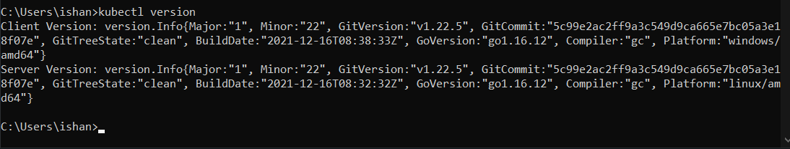Step 2) Run kubectl apply –f [filename]

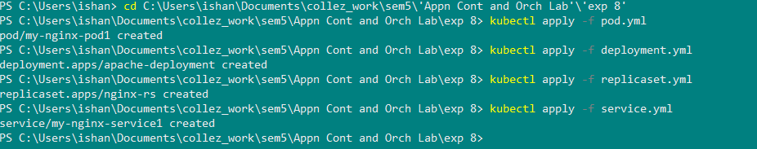

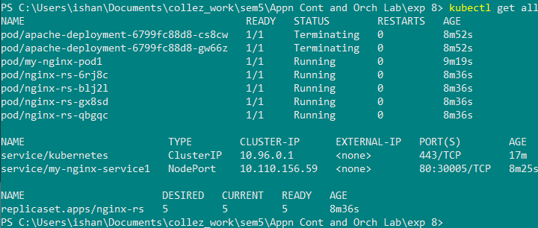Step 3) Run kubectl delete –f [filename]

